Tender No. 2 of 2023 -2024

OFFICE OF THE EXECUTIVE ENGINEER
PUBLIC HEALTH ENGINEERING DEPARTMENT
AIZAWL WATER DISTRIBUTION DIVISION NORTH, AIZAWL

TENDER DOCUMENT FOR CONSTRUCTION OF ZONAL TANK AT MUANNA VENG, AIZAWL
(UNDER SEDP)

Tender Amount | Rs. 51,36,000.00
Earnest Money | Rs. 1,02,720.00
Last Date of Sale of Tender | 1.4.2024 upto 11:00 Hrs.
Last Date of Submission of Tender | 1.4.2024 upto 12:00 Hrs.
Date of Opening | 1.4.2024 at 13:00 Hrs
Cost of Tender Document | Rs. 1000.00
Time Allowed for Execution of Work | 6 Months

PRESS TENDER NOTICE

The Sr. Executive Engineer, PHED, Aizawl Water Distribution Division North, Aizawl, on behalf of the Governor of Mizoram invites sealed tender in prescribed form from the eligible contractors of PHED, Govt. of Mizoram for the work cited below. The tender will be received in the office of the undersigned up to 12:00 hours on 01/04/2024. Late submission of tender will not be accepted. The tender so received will be opened on 01/04/2024 at 13:00 hours in presence of the intending tenderer or his authorized representative. If for any unforeseen reason, the tenders could not be received & opened on the stipulated date & time, the same will be received and opened in the next working day at the same time for which no separate communication will be made.

NIT No. | Name of work | Tendered Amount (Rs) | Earnest Money (Rs)  2% | Cost of Tender.  (in Rs)
2 of 2023 -2024 | Construction of Zonal Tank at Muanna Veng | Rs. 51,36,000 | Rs.1,02,720 | Rs.1,000

Detailed tender document may be obtained from the office of the undersigned on any working day from 18.03.2024 onwards on payment of tender cost as mentioned above (non -refundable) without which, the tender shall summarily be rejected.

The same may also be downloaded from PHED’s website at www.phed.mizoram.gov.in. If the documents are downloaded from the website, the cost of tender document shall be included in a separate envelope in the Technical Bid.
Sd/-
(LALHRUAIA)
Sr. Executive Engineer, PHED
Aizawl Water Distribution Division North,
Aizawl

Memo No.W-11013/2/2014/Tech/AWDD’N’/28 : Dated Aizawl the 15th March, 2024
Copy to-
- PS to Hon’ble Minister, PHED, Mizoram for favour of your kind information.
- The Secretary (PHED), Govt of Mizoram for favour of kind information.
- The Engineer-in-Chief (PHED), for favour of kind information.
- The Chief Engineer Zone-I (PHED), for favour of kind information.
- The Superintending Engineer (PHED),Aizawl WATSAN Circle, for favour information.
- The Director, Information and Public Relation Department, Govt. of Mizoram for information and necessary action with a request to publish the tender notice in 2 (two) issues of 2 (two) local newspaper.
- The System Analyst, PHED for information and upload of tender notice and documents to PHED’s website.
- Concerned file.
- Office notice board.

Sr. Executive Engineer, PHED
Aizawl Water Distribution Division North,
Aizawl

CONTENTS | Page No
Press tender notice | 1
Contents | 2
Notice inviting tender | 3-5
Purchase receipt of tender document | 6
Declaration of tenderer | 7
General conditions of contract | 8-11
General rules and directions | 12-13
General Specification & Special Conditions | 14-18
Bill of quantities | 19-20
Schedule of quantities | 21-22
Detail Drawing | 23-27
Power of attorney for signing of bid | 28
Bid security declaration form | 29

NOTICE INVITING TENDER

Item rate tender is invited on behalf of Governor of Mizoram from registered contractors/firms of PHED for the work: CONSTRUCTION OF ZONAL TANK AT MUANNA VENG (Under SEDP)
- The enlistment of contractor should be valid on the last date of sale of tender.
In case the last date of sale of tender is extended, the enlistment of contractor should be valid on the original date of sale of tender.
  - The work is estimated to cost Rs. 51,36,000.00 inclusive of all taxes viz. GST, Cess etc.
  - Tender will be issued to contractors registered under MPHED with definite proof from appropriate authority.

- Tender document consisting of work to be done and the set of terms & conditions may be seen in the office of the Sr. Executive Engineer PHED, Aizawl Water Distribution Division North between hours of 9:00 AM & 5:00 PM every day from 18/03/2024 except on Saturday and Sunday and public holidays.

- Tender document, excluding standard form, will be issued from this office, during the hours specified above, on payment of Rs. 1,000/- (Rupees One Thousand) only in cash.

- Receipt of application for issue of forms shall be closed by 11:00 Hrs on 01/04/2024. Receipt of tender shall be closed by 12:00 Hrs on 01/04/2024.

- Tender must be accompanied with earnest money of Rs. 1,02,720.00 in the form of bank guarantee/ fixed deposit receipt or demand draft of a scheduled bank in Mizoram issued in favour of the Sr. Executive Engineer, PHED, Aizawl Water Distribution Division North. The tender document along with supporting documents shall be placed in one sealed envelope marked ‘Technical Bid’. Another sealed envelope marked ‘Financial Bid’ shall contain only profoma of schedules (Schedule A). Both the envelopes shall be submitted together in another sealed envelope with the name of work and due date of opening written on it.

ELIGIBILITY cum TECHNICAL BID shall comprise of the following:
- GST registration
- Earnest money
- Power of attorney for signing of bid
- Bid security declaration
- Valid Enlistment of Contractor
- Tenderer should sign in each and every numbered page (i.e. blank pages need not be signed) as a token of acceptance of each and every terms of the tender document.
- Tender purchased receipt/cost of Tender Form downloaded from PHED Website.
- Site Visit Certificate with self photograph at site

FINANCIAL BID shall comprise of the following:
- Proforma of schedules (Schedule A)

- The bidder whose tender is accepted will be required to furnish performance guarantee of 3% (Three percent) of the bid amount within 10 days from issue of Letter of Intent. This guarantee shall be in the form of deposit at call receipt/ demand draft/ government securities/ fixed deposit receipts/ bank guarantee bonds of any scheduled bank in Mizoram. In case the selected bidder fails to deposit the said performance guarantee within the period as indicated, the contract shall be liable to be terminated.

- Canvassing whether directly or indirectly, in connection with tenderer is strictly prohibited and the tender submitted by the contractor who resort to canvassing will be liable to rejection.

- The tenderer shall not be permitted to tender for works in the Circle/ Division responsible for award and execution of contracts, in which his near relative is posted as Accounts Officer or as an officer in any capacity between the grades of Sr. Executive Engineer and Junior Engineer (both inclusive). He shall also intimate the names of persons who are working with him in any capacity or are subsequently employed by him and who are near relatives to any gazetted officer in the department. Any breach of this condition by the contractor would render him liable to be removed from the approved list of contractors of this department.

- No engineer of gazetted rank or other gazetted officer employed in engineering or administrative duties in the department is allowed to work as a contractor for a period of one year after his retirement from government service without the previous permission of the Government of Mizoram in writing. Engagement of any such official shall render the bid as invalid.

- The Government shall deduct CESS & GST, etc as admissible on the value of work done from each bill of the contractor as per prevailing government instruction/orders. In lieu, the department shall issue a certificate of deduction of the tax at source to the contractor.

- A copy of the receipt for the money deposited against purchase of tender document shall have to be submitted along with the tender as a proof of purchasing the same. If the document is downloaded from the website, the cost of tender documents may be included in a separate envelope in the technical bid.

- Tenderer has to read all terms and conditions of this tender documents carefully. Tenderer has to accept and comply with all terms and conditions of this tender. Overwriting in the proforma of schedules is not acceptable and corrections, if any should be initialled and dated by the tenderer.

- Defect liability period of the contract shall be 6 (Six) months from the date of commissioning. Any defect noticed in the construction works during this period shall have to be rectified by the contractor at his/their own cost and risk.

- The Public Health Engineer Department, Govt. of Mizoram reserves the right to reject or accept any or all tenders wholly or partly with proper reason on the ground considered advantageous to the department whether it is the lowest tender or not.

- The Public Health Engineer Department, Govt. of Mizoram takes no responsibility for delay, loss or non-receipt of tenders sent by post. Unsealed tenders shall not be considered for acceptance.

- The tender document shall remain the property of the Public Health Engineering Department, and if obtained by one intending tenderer, shall not be used by any other tenderer.

- The tender shall be completely filled in all respects and shall be tendered together with requisite information. Any tender incomplete in any particular shall be liable to be rejected.

- The tendering authority reserves the right to select any qualified bidder for the tendered work given there is sufficient evidence that it is in the best interest of the quality of work.

- The terms, conditions and specifications mentioned in tender document shall be binding on tenderer and no condition or stipulation contrary to the conditions shall be acceptable. It may please be noted that the tenderer who do not accept terms and conditions stipulated in this tender document, their offers shall be liable to be rejected without assigning any reason whatsoever. Tenderer should sign in each and every numbered page (i.e. blank pages need not be signed) as a token of acceptance of each and every terms of the tender document. The pages of the tender should be submitted in proper way in an organized manner.

- Tenderer must visit the proposed project site to conduct thorough site survey and techno-economic feasibility studies of the project on his own expenses. The tenderer shall also obtain a site visit certificate from the concerned JE which will be verified by SDO, Aizawl North Water Distribution Sub-Division, North-I, and shall be submitted in original along with the tender.

- Sub-letting of the works through sub-contract without the prior knowledge of the department will not be allowed. Prior permission in writing should be taken from the engineer-in-charge.

- The date of starting the work will be 15 days from the date of signing agreement. Contract agreement shall be signed within 10 days from issue of LOI.

( LALHRUAIA )
Sr. Executive Engineer, PHED
Aizawl Water Distribution Division North,
Aizawl

PURCHASE RECEIPT OF TENDER DOCUMENT

Item rate tender &contract for work

- Tender No : 2 of 2023-2024

For the work of CONSTRUCTION OF ZONAL TANK AT MUANNA VENG (Under SEDP)
- To be submitted latest by 12:00 hours on 01/04/2024
(D) To be opened at 13:00 hours on 01/04/2024

Issued to : ……………………………………..…………………………………………………………..

……………………………………………………………………………………………………...

Signature of officer issuing the document …………………………

Designation : ...............................................................................

Date of Issue : …………………

DECLARATION OF TENDERER

I/We have read and examined the notice inviting tender& its clauses of contract, general conditions of contract, general rules and directions, scope of works, bill of quantities, schedule of quantities and all other contents in the tender document for the work.

I/We hereby tender for the execution of the work specified for the Governor of Mizoram within the time specified and in accordance to all respect with the instructions in general conditions of contract, general rules and directions.

A sum of Rs. 1,02,720.00 is hereby forwarded as earnest money in the form of bank guarantee/ fixed deposit receipt or demand draft of a scheduled bank in Mizoram. I/We agree to furnish the prescribed performance guarantee within prescribed period, failing which the department have the right to black list me/us and will not bid any contract under Public Health Engineering Department for a period of 2 (years). Further, if i/we fail to commence work as specified, i/we agree without prejudice to any other right or remedy available in law that the said performance guarantee shall be forfeited for the property of the Government of Mizoram.

I/We hereby declare that i/we shall treat the tender document and records connected with the work as secret/confidential documents and shall not communicate information/derived there to any person other than a person to whom i/we am/are authorized to communicate the same or use the information in any manner prejudicial to the safety of the State.

Dated:

Witness Tenderer

Signature: Signature:

Name : Name:

Postal address:Postal Address:

Mobile number: Mobile number:

GENERAL CONDITIONS OF CONTRACT

1. Signing of contract |  | Successful tenderer/contractor, on acceptance of his tender by the accepting authority, shall, within 5 days from the date of issue of letter of intent, sign contract agreement.
2. Performance guarantee | i | Contractor shall submit an irrevocable performance guarantee of 3% (three percent) of his bid amount within 10 (ten) days from the date of issue of LOI.
 | ii | The performance guarantee shall be valid up to the stipulated date of completion plus 60 days beyond that.
 | iv | In the event of the contract being terminated or rescinded, the performance guarantee shall stand forfeited in full and shall be absolutely at the disposal of the Governor of Mizoram.
3. Recovery of security deposit | An amount of 5% of the gross amount of each bill shall be deducted as a security deposit. This amount shall be released after completion of maintenance period.
4. Compensation for delay | - For delay of work, the contractor shall pay compensation to the government @ 1.5% per month not exceeding 10% of the tendered value of work or of the tendered value of the item or group of completed items of work.  - The amount of compensation may be adjusted or set-off against any sum payable to the contractor under this or any other contract with the Government.
5. Terms and conditions of payment | - Payment will be made to the contractor in time on submission of bills based on progress of the work subject to availability of fund.  The contractor shall be at liberty to submit bills for payment every month during the construction period. While payment of such bills, an amount of 2.5% of the gross amount of each bill shall be deducted as a security deposit.
6. Materials to be provided by the contractor | The contractor shall, at his own expense, provide all materials, required for the works other than those which are stipulated to be supplied by the government.
7. Work to be executed in accordance with specifications, drawings, orders, etc. | The contractor shall execute the whole and every part of the work in the most substantial and work man like manner both as regards materials and otherwise in every respect in strict accordance with the specifications. The contractor shall also conform exactly, fully and faithfully to the drawings and instructions in writing in respect of the work signed by the engineer-in-charge and the contractor shall be furnished free of charge one copy of the contract documents together with specifications, drawings and instructions as are not included in the standard specifications of Central Public Works Department or in any Bureau of Indian Standard or any other, published standard or code or schedule of rates or any other printed publication referred to elsewhere in the contract.  The contractor shall comply with the provisions of the contract and with the care and diligence execute and maintain the works and provide all labor and materials, tools and plants including for measurements and supervision of all works, structural plans and other things of temporary or permanent nature required for such execution and maintenance in so far as the necessity for providing these, is specified or is reasonably inferred from the contract. The contractor shall take full responsibility for adequacy, suitability and safety of all the works and methods of construction.
8. Suspension of work | (i) The contractor shall, on receipt of the order in writing of the engineer-in-charge, (whose decision shall be final and binding on the contractor) suspend the progress of the works or any part thereof for such time and in such manner as the engineer-in-charge may consider necessary so as not to cause any damage or injury to the work already done or endanger the safety thereof:  The contractor shall, during such suspension, properly protect and secure the works to the extent necessary and carry out the instructions given in that behalf by the engineer-in-charge.
9. Action in case work not done as per specifications | All works under or in course of execution or executed in pursuance of the contract, shall at all times be open and accessible to the inspection and supervision of the engineer-in-charge, his authorized subordinates in charge of the work and all the superior officers, officers of the quality assurance unit of the department or any organization engaged by the department for quality assurance and of the Chief Technical Examiner’s office, and the contractor shall, at all times, during the usual working hours and at all other times at which reasonable notice of the visit of during the usual working hours and at all other times at which reasonable notice of the visit of such officers has been given to the contractor, either himself be present to receive orders and instructions or have a responsible agent duly accredited in writing, present for that purpose. Orders given to the contractor’s agent shall be considered to have the same force as if they had been given to the contractor himself.
10. Contractor liable for injuries,  damages, defects | If the contractor or his working people, equipments or machineries cause injury to human/animals or break, deface, destroy any property or cause any damage to any item of the work, from any cause whatever or if any defect or other faults appear in the work, the contractor shall upon receipt of a notice in writing on that behalf make the same good at his own expense.
11. Contractor to supply tools &plants etc. | The contractor shall provide at his own cost all materials, machinery, tools & plants required for work execution and maintenance.
12. Labor laws to be complied by the contractor  13. Work to be executed as per the approval of Engineer incharge | (i) The contractor shall obtain a valid license under the Contract Labour (R&A) Act, 1970, and the Contract Labour (Regulation and Abolition) Central Rules, 1971, before the commencement of the work, and continue to have a valid license until the completion of the work. The contractor shall also abide by the provisions of the Child Labour (Prohibition and Regulation) Act, 1986.  The contractor shall also comply with the provisions of the building and other Construction Workers (Regulation of Employment & Conditions of Service) Act, 1996 and the building and other Construction Workers Welfare Cess Act, 1996.  Any failure to fulfill these requirements shall attract the penal provisions of this contract arising out of the resultant non-execution of the work.
 | (ii) No labour below the age of eighteen years shall be employed on the work.
 | (iii) The engineer-in-charge may require the contractor to dismiss or remove from the site of the work any person or persons in the contractors’ employ upon the work who may be incompetent or misconduct himself and the contractor shall forthwith comply with such requirements. In respect of maintenance/ repair or renovation works etc. where the labour have an easy access to the individual houses, the contractor shall issue identity cards to the laborers, whether temporary or permanent and he shall be responsible for any untoward action on the part of such labour. AE/JE will display a list of contractors working in the colony/Blocks on the notice board in the colony and also at the service centre, to apprise the residents about the same.
 | All works to be executed under the contract shall be executed under the direction and subject to the approval of the engineer-in-charge who shall be entitled to direct at what point or points and in what manner they are to be commenced, and from time to time carried on.
14. Settlement of disputes & arbitration | All questions and disputes relating to the meaning of the specifications, drawings and instructions here-in before mentioned and as to the quality of workmanship or materials used on the work or as to any other question, claim, right, matter or thing whatsoever in any way arising out of or relating to the contract, drawings, specifications, estimates, instructions, orders or these conditions or otherwise concerning the works or the execution or failure to execute the same whether arising during the progress of the work or after the cancellation, termination, completion or abandonment thereof shall be dealt by a Dispute Redressal Committee duly constitute by the State Government:
15. Levy /taxes payable by contractor | (i) Sales tax/VAT/ GST, etc. Building and other Construction Workers Welfare Cess or any other tax or Cess in respect of this contract shall be payable by the contractor and government shall not entertain any claim whatsoever in this respect.
16. Termination of contract on death of contractor | Without prejudice to any of the rights or remedies under this contract, if the contractor dies, the divisional officer on behalf of the Governor of Mizoram shall have the option of terminating the contract without compensation to the contractor.

GENERAL RULES AND DIRECTIONS

Officer inviting Tender: | Sr. Executive Engineer, PHED., Aizawl Water Distribution Division North

Definitions:
2(v) | Engineer-in-charge | Executive Engineer, PHED  Aizawl Water Distribution Division North.  or  Concerned Sub-Divisional Officer
2(viii) | Accepting authority | Chief Engineer Zone-I, PHED. Mizoram
2(xi) | Standard schedule of rate | MPWD/MPHED Schedule of Rates
2(xii) | Department | PHE Department
9(ii) | Latest standard CPWD Contract Form GCC | Applicability of the Clauses under CPWD Form 8 for this particular tender are listed below

Clause 1:
1 | Time allowed for submission of performance guarantee from the date of issue of letter of intent: | 10 Days
2 | Maximum allowable extension beyond the period  provided in (1) above | 5 Days
Clause 1(A):
I | Security deposit | 5% of the tendered amount

Clause 2:
I | Authority for fixing compensation under clause 2: | SE

Clause 2A (Incentive for early completion):
i | Whether Clause 2A shall be applicable | No

Clause 3& 3A (When contract can be terminated):Applicable.

Clause 4 (Contractor liable to pay compensation even if action not taken under Clause3):Applicable.

i | Number of days from the date of issue of letter of intent for reckoning date of start: |  | 15 Days
ii | Milestone(s) as per table given below:-
Sl. No | Description of milestone (Physical) | Time allowed in days for execution of work (from date of start) |  | Amount to be withheld in case of non-achievement of milestones
 | No description of milestone (Physical) in The DPR | As before column |  | Penalty clause applicable as per clause-2 of CPWD Form-8.
 | “NIL” | “ NIL”
iii | Time allowed for execution of work:: | 6 Months
iv | Authority to decide:
 | - Extension of time: As per CPWD Works Manual
 | - Rescheduling of mile stones : SE i/c

List of mandatory machinery, tools & plants to be owned or leased by the contractor are as follow. Contractor has to list down the items with quantity, owned or leased and related documents must be furnished.

Sl.No. | Item Description | Quantity | Unit | Owned/Leased
1 | Concrete Mixer (I Bag capacity or more) | 1 | No
2 | Needle Vibrator (Electric/Engine driven) | 2 | No
3 | Safety equipments
 | - First Aid kits | 2 | No
 | - Ropes | 2 | No

GENERAL SPECIFICATIONS AND SPECIAL CONDITIONS

1 Materials and methods of construction for all civil works shall be as per relevant Indian standard specification, part of which are incorporated in the standard specification of PHED and MPWD and all will be followed during the execution of the work. The work shall be executed as per the guidelines and provisions of B.I.S. All materials shall conform to Indian standard code of practice National Building Code and CPHEEO manual to maintain quality of work.
2 All materials to be used shall conform to the relevant specifications as per the latest version of the Indian Standards, unless otherwise stated in the detailed specifications of items of work. A set of specimen samples of all approved materials shall be kept in bottle or otherwise at site, cost of which is to be borne by the contractor.
3 Water required for the execution of the work and for the water tightness test of water retaining structure shall be supplied by the contractor at his own cost in satisfactory manner to the Engineer-in-Charge of work.

4 The source from which sand is to be obtained shall be subject to the approval of Engineer-in-charge. The sand shall be clean, sharp and gritty to touch and be freed from earth and other impurities by washing. The sand shall be washed to such a degree that when a handful is mixed with clean water in a glass and allowed to stand for an hour the precipitate of mud over the sand shall not exceed 5%. The sand should conform to IS 382-1982 for fine and coarse aggregates from natural sources. The aggregate shall consist of stone ballast of quality approved by Engineer-in-charge and shall consist of graded size 20 mm and down wards as per specification or the size mentioned in the item description.
5 Cement
Low heat Portland cement conforming I.S. 12600 or PPC conforming to IS: 1489 (Part 1 & 2) shall be used prior to approval the Engineer-in-charge. All cement shall be fresh when delivered. Cements of different types are not to be mixed with one another. Consignments shall be used in the order of delivery. Admixture, if any, shall be used only after approvals.
6 Reinforcement
Steel reinforcement shall be of mild steel of tested quality conforming to I.S.- 432 -1966/ H.Y.S.D. bars conforming to IS -1786/1779- with latest amendments of reputed make.
All the reinforcement shall be clean and free from rust, mild scales, dust, paint, oil, grease, adhering earth or any other material or coating that may impair the bond between the concrete and the reinforcement, or cause corrosion of the reinforcement or disintegration of concrete.
Neither the size nor length of bar or wire shall be less than the size or length described in the bar schedule or elsewhere and the length shall not be more than 50 mm in excess of the length as described.
Welded joints in reinforcement may be used but in cases of important connection, tests shall be made to prove that the joints are of the full strength of bars connected, welding of reinforcement shall be done in accordance with the recommendations of the relevant Indian standards for welding mild steel bars used in the reinforcement concrete construction.
Bending and overlapping, placing in position, fabrication, binding, reinforcement with wire of approved gauge shall be done as per I.S. 432 – 1960 (revised) and I.S. 1786 – 1966 and I.S. 2502 (revised). Handling and storage of materials for concrete or RCC should be followed as per I.S. 4082 –1977.
7 Water
The water to be used in making and curing of concrete, mortar etc. shall be free from objectionable quantities of silts, organic matter, injurious amount of oils, acids, salts and other impurities etc. as per IS-456-1978. The Engineer-in-charge or his authorized representatives will determine whether such quantities of impurities are objectionable.
Such comparison will usually be made by comparison of compressive strength, water requirement, time of setting and other properties of concrete made with distilled or every clean water and concrete made with the water proposed for use, Permissible limit for solids when tested in accordance with I.S. 3025-1964.
If any water to be used in concrete, suspected by the engineer-in-charge/or his authorized representative of exceeding the permissible limits of solids, samples of water will be obtained and get it tested by Engineer-in-charge in accordance with IS:3025-1964.
8 Cement Mortar
The motor shall consist of cement and sand mixed in proportion defined in relevant schedule item for various item of work. Only measured quantity shall be used. The sand shall be shoveled in a wooden measure of a clean masonry platform, after removing the measure box and spreading out sand if necessary, the cement (in required proportion) shall be emptied on the top of sand.
The sand and cement shall be then turned over with shovels once dry and made into the form of a hollow cone; into this water can be poured and the whole shall then be turned over completely twice. The color and consistency shall at this stage be quite uniform, if not, further turning shall be done.
Water shall be added by measured quantities if the engineer so direct. Only such quantities of mortar shall be mixed at one time as can be used at once before it can set. No mortar, which has once caked or begun to set, shall be used, nor shall such mortar be remixed; but it shall be removed from the site of the work immediately.
9 Cement concrete
The concrete shall consist of an aggregate of the proportion by volume defined in relevant schedule item or work. Only measured quantity shall be used.
9.1 Laying: The cement, sand and aggregate shall be mixed properly in mechanical mixer in such a manner as to avoid loss of water. The concrete shall be mixed for minimum period of 2 minutes or unit it is of even colour and uniform consistency throughout. As soon as the concrete is mixed it should be removed to the work site with conveyor or pipe rapidly as practicable. The concrete laid will be vibrated for compaction by the vibrators. Slum test will be carried at site during execution of work.
9.2 Curing: The concrete laid shall not be disturbed and shall be kept thoroughly damped by means of wet matting and sand until it shall have become thoroughly set and hard enough to prevent its drying and cracking.
Curing period for PCC shall be 14 days minimum. Use of curing compound shall be opted as per manufacturer’s specification.
9.3 Formworks: The contractor shall furnish on the site of work sufficient number of centering, moulds or templates for its expeditious execution. The forms shall be made in such a way and of such materials as will ensure a smooth surface on the finished concrete. Forms and centering shall be left in place until the concrete has set sufficiently to permit the removal without danger to the structure.
10 Reinforced Cement Concrete
All R.C.C. work shall be of the grade M-30 as given in specifications and as provided in latest IS: 456-2000 (Amendment). The materials will be measured when dry. The aggregates should be thoroughly washed in clean water and stacked.
For water retaining structure minimum grade of concrete shall be M-30 (IS:3370 latest)
10.1 Laying: Cement, sand and stone chips shall be mixed properly in a mechanical mixer in such a manner as to avoid loss of water. The concrete shall be mixed for minimum period of 2 minutes or until it is of even color and uniform consistency throughout. As soon as the concrete is mixed it should be removed to the work in iron vessels as rapidly as practicable. The concrete laid will be vibrated for compaction by vibrators. Slum test will be carried at site during execution of work.
2.10.2 Curing: The concrete laid should not be disturbed and shall be kept damped by means of wet matting and sand until it shall have become thoroughly set and hard enough to prevent its curing and cracking.
The aggregate shall consist of stone ballast of quality approved by Engineer-in-charge and shall consist of graded size 20 mm and downwards as per IS and CPHEEO specification or the size mentioned in the item description.

10.3 Formwork: Contractor shall furnish on the site of work sufficient number of centering, forms, moulds or templates for its expeditious prosecution, the forms shall be made in such as way and such material as will ensure a very smooth surface on the finished concrete. Forms and centering shall be left in place until the concrete has set sufficiently to permit the removal without danger to the structure.
10.4 Reinforcement: Steel bars for reinforcing concrete shall be of such shape to afford an approved mechanical bond with concrete to ensure intimate control between steel and concrete.
Steel reinforcement shall be either mild steel of tested quality confirming to IS-432-1996 or cold worked stool high strength deformed bars as per IS-1786-1979 in strength grade Fe-415 or hot rolled high yield strength steel deformed bars with minimum yield strength of 425 N/mm as per IS – 1939 –1966 (Amended 1968) Reinforcement bars will be rejected if the actual weight various more than 5% from the standard weight.
All bars must conform to the requirement of Indian standard specification. They shall be protected at all time before placed in the concrete from mechanical injury and the weather and when please in the work, they shall be free from dirt, scales, loose or scaly rust, point and oil.
Bars which are to be embodied in concrete but remain exposed for some time after being placed in the work shall, if directed be immediately coated with a thin grout of equal part of cement and sand. Bars shall be bent to the shape shown on the drawings and in conforming to approved templates. When bars are cut and bent on the wok the contractor shall employ competent men and provide the necessary appliances for the purpose.
All steel shall be rigidly held in place with 18 gauge annealed steel wire, cement mortar (1:2) cubes. M.S. chairs and spacer shall be used in order to ensure accurate positioning of reinforcement. All joints in steel reinforcement shall be overlapped. The length of overlap for tension and compression shall be as per the requirement of Indian standard specification.
In water retaining structures a clear cover of 40 mm from the face of the steel should be provided.
11 Cement Plaster
12 mm thick cement plaster in (1:3) proportion shall be applied on outside surface of all concrete works from 30cm below ground level up to top. The surface in contact with water will have 15 mm thick cement plaster of not less than (1:3) proportion with 3% water proofing compound. The concrete surface shall be properly hacked, washed, cleaned and applied with thick cement slurry before applying.
The plaster shall be protected from sun, rain and frost at the contractors expense by such means as the engineer may approve.
To protect the plaster from the sun, ordinarily the whole surface shall be covered with wet sacks. The contractor shall keep the plaster continuously wetted for a period of seven days after application.
12 Painting
All concrete surfaces shall have two coats of emulsion paint over a coat of priming as specified by the manufacture of the paint.
The make, shade and color of the paints shall have to be approved by the Engineer-in-charge before use.

SPECIAL CONDITIONS
1. Electricity will be provided by the Contractor.
2. The work will be carried out in the manner complying in all respects with the requirements of relevant bye laws of the local body under the jurisdiction of which the work is to be executed or as directed by the Engineer in charge and nothing extra will be paid on this account.
4. Samples of various materials required for testing shall be provided free of charges by the contractor. Testing charges and all other expenditure required to be incurred for taking the samples, conveyance, packing etc. shall be borne by the contractor himself.
5. The contractor shall bear all incidental charges for cartage, storage and safe custody of materials.
6. The contractor shall have to make approaches to the site, if so required and keep them in good condition for transportation of labour and materials as well as inspection of works by the Engineer in charge. Nothing extra shall be paid on this account.
7. No payment will be made to the contractor for damage caused by rains, or other natural calamities during the execution of the works and no such claim on this account will be entertained.
8. Wherever work is specified to be done or material procured through specialized agencies, their names shall be got approved well in advance from Engineer in 22 charge. Failure to do so shall not justify delay in execution of work. It is suggested that immediately after award of work, contractor should negotiate with concerned specialist agencies and send their names for approval to Engineer in charge. Any material procured without prior approval of Engineer in charge in writing is liable to be rejected. Engineer in charge reserves right to get the materials tested in laboratories of his choice before final acceptance. Non standard materials shall not be accepted.
9. The contractor shall maintain the time bound progress for the execution of work and got it approved by the Engineer in charge.
10. The contractor shall take instruction from the Engineer in charge for stacking of materials at any place. No excavated earth or building material shall be stacked on areas where other buildings, roads, services or compound walls are to be constructed.

BILL OF QUANTITIES

PROFORMA OF SCHEDULES
Schedule ‘A’

SCHEDULE OF QUANTITIES

Sl No | Description of Work | Quoted Amount in figure (Rs) | Quoted Amount in words (Rs)
1 | Earthwork in excavation over areas including disposal of excavated earth etc.  a)Ordinary & hard soil
2 | Providing and laying in position cement concrete of specified grade excluding cost of centering and shuttering  a) 1:1.5:3 (20mm nominal size)
3 | Providing and laying in position reinforced cement concrete excluding cost of centering and shuttering  a) 1:1.5:3 (20mm nominal size)
4 | Reinforced cement concrete work in walls including attached pillasters, columns, pillers, posts, piers, abutments, return walls, retaining walls, struts, buttresses, string or lacing courses, fillets etc. upto floor five level excluding cost of centering shuttering etc complete.
5 | Centering and shuttering including strutting, propping etc. and removal of form for all heights
 | a) Foundations, footings, bases of columns etc. for mass concrete
 | b) Walls including attached pillasters, buttresses, string courses, etc.
 | c) Columns, pillars, piers, abutments, posts and struts.
 | d) Lintels, beams, plinth beams, girders, bressumers and cantilevers, etc.
 | e) Suspended floors, roofs, landings, shelves and their support, balconies and chajjaj,etc.
6 | Steel reinforcement for RCC work including straighthening, cutting, bending, placing in position and binding all complete.  b) Thermo-Mechanically Treated bars of grade Fe-500 or more.
7 | Extra for providing richer or leaner mixes respectively at all floor levels.  b) Providing M-30 grade concrete instead of M-20 grade BMC/ RMC.
8 | 20mm cement plaster 1 : 3 (1 cement : 3 fine sand).  Applying both inner and outer walls
9 | Extra for providing and mixing water proofing materials in proportion recommended by manufacturer in -  c) 15mm cement plaster 1 : 3 (1 cement : 3 fine sand)
10 | Finishing walls with water proofing cement paint of approved brand and manufacture and of required shade to give an even shade. New work (two or more coats)
11 | Finishing walls with high performance  elastomeric decorative exterior water proofing coating of approved brand and of required shade on new work .
RETAINING WALL
12 | Earthwork in excavation over areas including disposal of excavated earth etc.  a)Ordinary & hard soil
13 | Providing and laying in position cement concrete of specified grade excluding cost of centering and shuttering  a) 1:1.5:3 (20mm nominal size)
14 | Providing and laying in position reinforced cement concrete excluding cost of centering and shuttering  a) 1:1.5:3 (20mm nominal size)
15 | Reinforced cement concrete work in walls including attached pillasters, columns, pillers, posts, piers, abutments, return walls, retaining walls, struts, buttresses, string or lacing courses, fillets etc. upto floor five level excluding cost of centering shuttering etc complete.
16 | Regular coursed rubble masonry with hard stone in foundation upto one storey above and below ground level including curing, etc. complete  a) in cement mortar 1 : 3 ( 1cement : 3 fine sand)
17 | Centering and shuttering including strutting, propping etc. and removal of form for all heights
 | a) Foundations, footings, bases of columns etc. for mass concrete.
 | c) Columns, pillars, piers, abutments, posts and struts.
 | d) Lintels, beams, plinth beams, girders, bressumers and cantilevers, etc.
18 | Steel reinforcement for RCC work including straighthening, cutting, bending, placing in position and binding all complete.  b) Thermo-Mechanically Treated bars of grade Fe-500 or more.
19 | 15mm cement plaster 1 : 3 (1 cement : 3 fine sand).  Face of R.Wall
20 | Finishing walls with water proofing cement paint of approved brand and manufacture and of required shade to give an even shade. New work (two or more coats)  Face of R.Wall
 | Total

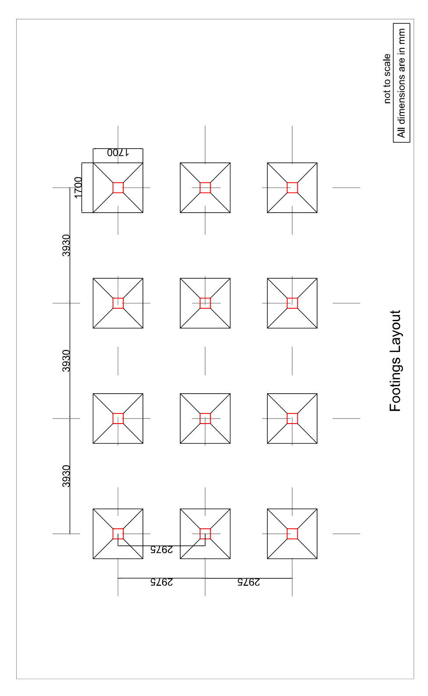
DRAWINGS FOR MUANNA VENG ZONAL TANK
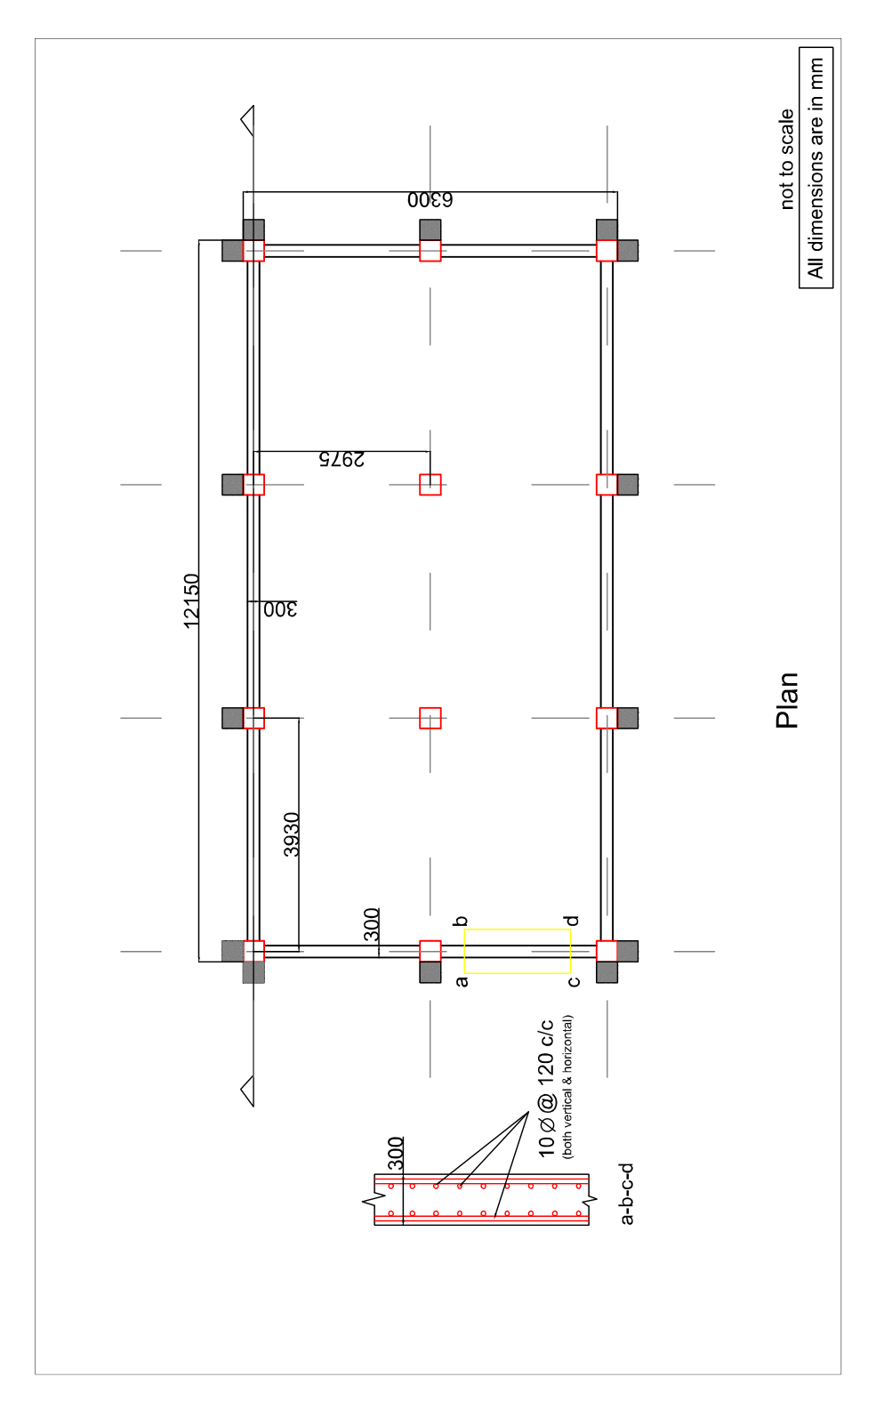

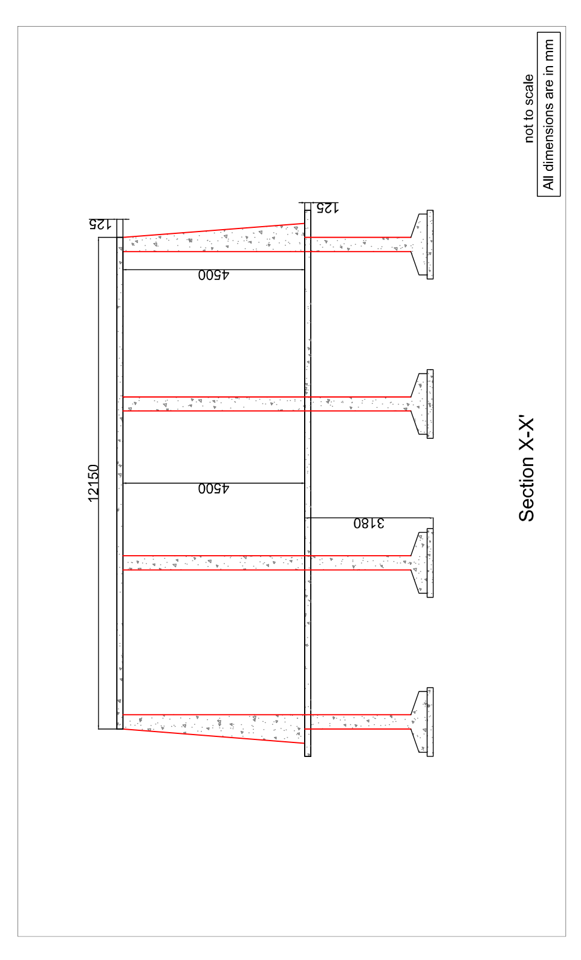

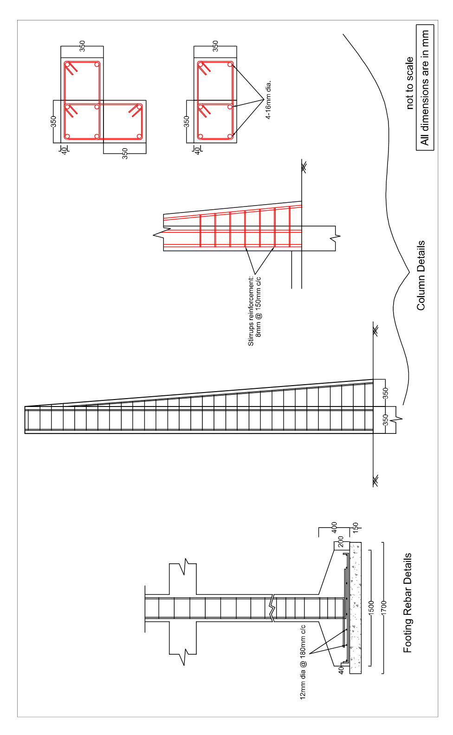

DRAWING FOR RETAINING WALL AT MUANNA VENG ZONAL TANK
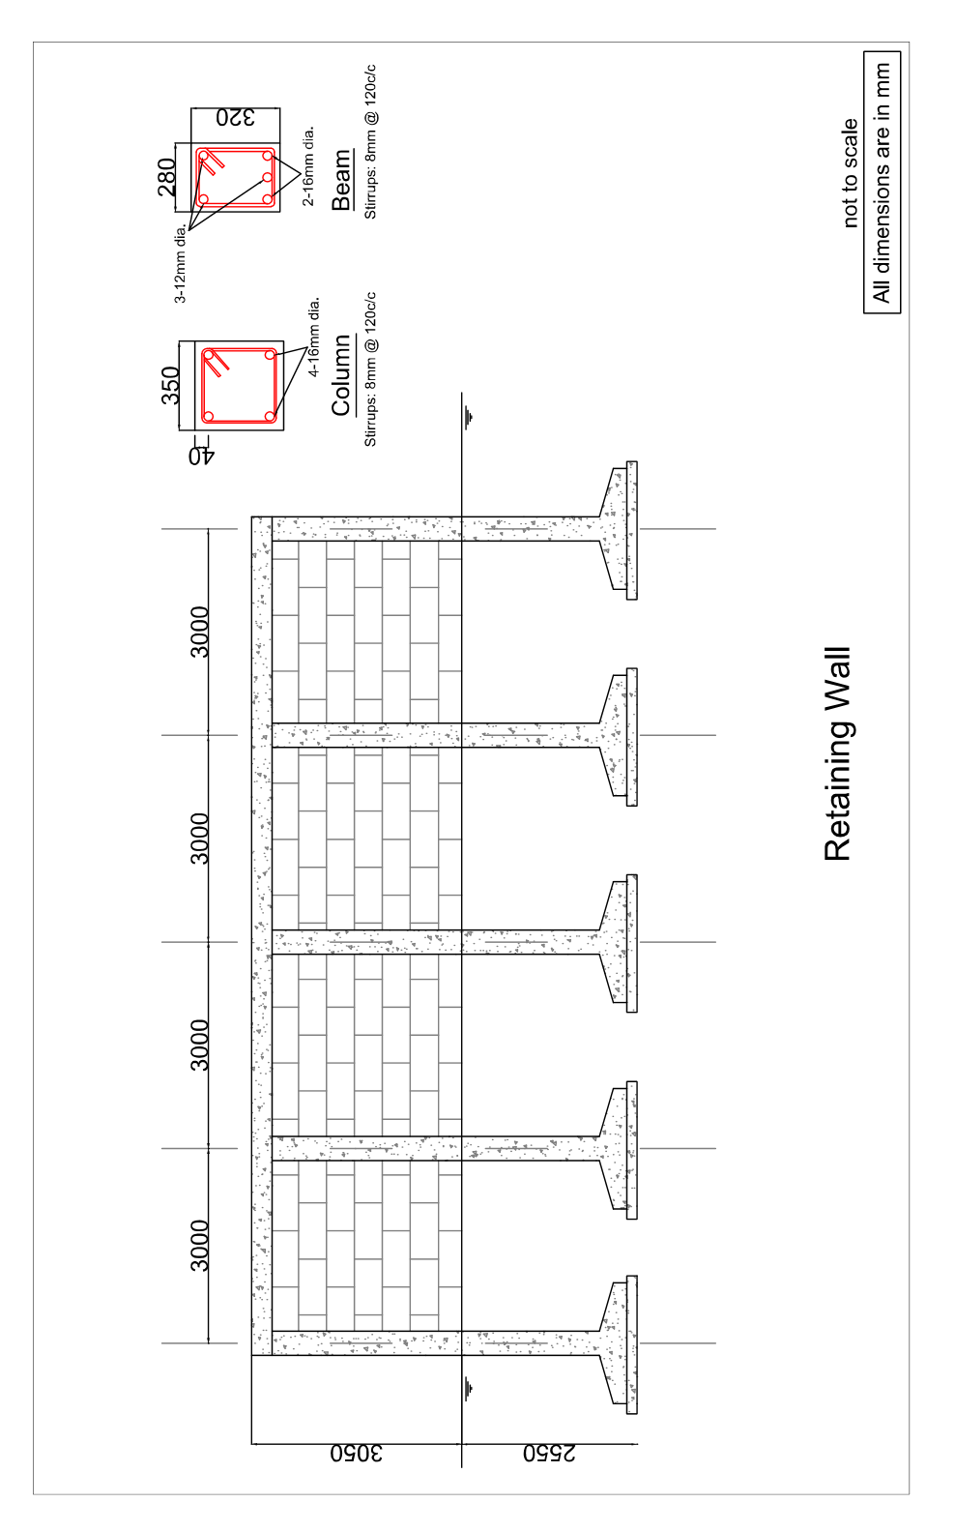

POWER OF ATTORNEY FOR SIGNING OF BID

Know all men by these presents, We…………………………………………….. (name of the Bidder/Firm and address of the registered office) do hereby irrevocably constitute, nominate, appoint and authorize Mr./ Ms (name), …………………… son/daughter/wife of…………………… and presently residing at…………………., who is presently employed with us as our true and lawful attorney (hereinafter referred to as the “Attorney”) to do in our name and on our behalf, all such acts, deeds and things as are necessary or required in connection with or incidental to submission of our BID(s) for the ______________ [name of Work] proposed by the ________(name of Department) including but not limited to signing and submission of all BIDs, and other documents and writings, participate in conferences/ meetings and providing information/ responses to the Authority, representing us in all matters before the Authority, signing and execution of all contracts and undertakings consequent to acceptance of our bid[s], and generally dealing with the Authority in all matters in connection with or relating to or arising out of our bid for the said Work[s] and/ or upon award thereof to us and/or till the entering into of the contract with the Authority.

AND we hereby agree to ratify and confirm and do hereby ratify and confirm all acts, deeds and things lawfully done or caused to be done by our said Attorney pursuant to and in exercise of the powers conferred by this Power of Attorney and that all acts, deeds and things done by our said Attorney in exercise of the powers hereby conferred shall and shall always be deemed to have been done by us.

In witness whereof we, …………………………., the above named principal have executed this power of attorney on this ……… day of…. 2

For
(Signature)
(Name, Title and Address)
Witnesses:
1.
2.
……………………………
(Signature)
(Name, Title and Address of the Attorney)
(Notarised)
Person identified by me/ personally appeared before me/
signed before me/ Attested/ Authenticated*
(*Notary to specify as applicable)
(Signature, Name and Address of the Notary)
Seal of the Notary
Registration Number of the Notary
Date:__________
Notes: 1. The mode of execution of the Power of Attorney should be in accordance with the procedure, if any, laid down by the applicable law and the charter documents of the executant(s) and when it is so required, the same should be under common seal affixed in accordance with the required procedure.
- Also, wherever required, the BIDDER should submit for verification the extract of the charter documents and documents such as a resolution/ power of attorney in favour of the person executing this Power of Attorney for the delegation of power hereunder on behalf of the BIDDER.

BID SECURITY DECLARATION FORM

(The Bidder shall complete in this form in accordance with the instructions indicated)
Date :…………………………………………(insert date as day, month and year) of bid submission
Tender No…………………………………………………
To:

We/I, the undersigned, declare that:-
1 We/I understand that, according to your conditions, bids must be supported by a Bid Security Declaration.
2 We/I accept that we will automatically be suspended from being eligible for bidding in any contract under your department for a period of 2 (two) years upon receipt of your blacklisting order, if i/we are in breach of our obligation(s) under the bid conditions, because i/we:-
a) withdraw our bid during the period of bid validity specified or
b) having been notified of the acceptance of our bid by the purchaser during the period of bid validity,
i) fail or refuse to execute the contract, if required, or
ii) fail or refuse to furnish the performance guarantee
3I/we understand that this Bid Security Declaration shall expire if we are not the successful bidder, upon the earlier of
- our receipt of a copy of your notification of the name of successful bidder, or
- twenty-eight days after the expiration of our tender

Signed:
Name: ………………………………………………………………
Date : …………………………….

