No.M-11011/2/2013-E-in-C/PHE/Vol-III/86
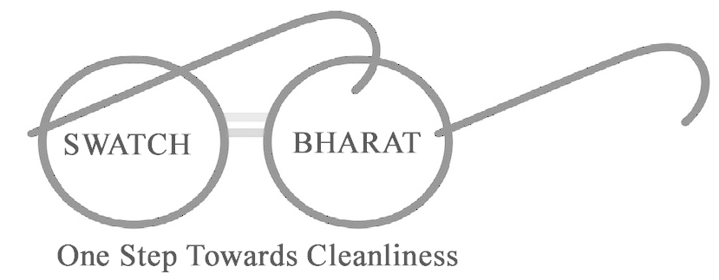
GOVERNMENT OF MIZORAM
OFFICE OF THE ENGINEER-IN-CHIEF:PHED
MIZORAM :: AIZAWL
Dated Aizawl, the 29th April, 2015.

NOTICE INVITING QUOTATION NO. 6 OF 2015 – 2016

Sealed Quotation is hereby invited on behalf of the Governor of Mizoram by the undersigned from Dealer/Authorised dealer for fixing the rate of material under mentioned below:

The Quotationers should submit their quotation with detailed specification with other relevant documents upto 12:00 Noon on 29.5.2015 and the Quotation will be opened on the same date at 2:00 Pm The Quotationer or their representative may be present at the time of opening in the office chamber of the undersigned.

Sl No. | Description of Item | Unit | Probable Cost  (in Rs.) | Quoted rate
 |  |  |  | In figure | In words
1 | ERW Pipe 350mm Ø, 7.1mm wall thickness, conforming to API-standard 5L, Grade X-42, PSL I, having test pressure 100kg/cm², in random length of 4 to 7 mtrs for GAWSS Ph-I | Rm | 50,00,000
2 | ERW Pipe 355.6mm Ø, 8.7mm wall thickness, conforming to API-standard 5L, Grade X-46, having test pressure 135kg/cm², in random length of 4 to 7 mtrs for Greater Lunglei WSS. | Rm | 50,00,000
Total : |  |  | 100,00,000.00

(Rupees One crore) only

TERMS & CONDITION

. Valid authorization certificate for the State of Mizoram obtained from the manufacturer of ERW Pipe should be attached.
2. The quotation is invited for fixing approved rates and approved suppliers for supply of materials of standard quality as per ISI/BIS standard/specifications etc rates will be valid for a period of one year from the date of acceptances or till re- fixation is considered necessary by the Department.
Cont….2/-

::2::

3. The material should be of standard quality as per ISI/BIS standard/specification preferably with ISO Certified quality mark.
4. Original/Certified legible copies of product brochure/Catalogue of the said item
should be attached.
5. Rate should be FIRM, quoted both in figure and in words per running metre.
6. The quotation should be submitted in a sealed cover with quotation notice No. & Date inscribed on the envelope.
7. Rate quoted should be FOR,Aizawl/Lunglei Mizoram inclusive of all types of taxes, Mizoram VAT, insurance, loading & unloading including stacking charges etc. complete in all respect and no escalation/discount will be entertained afterwards during the period of the validity of the quotation.
8. Quotationers should write clearly the following information for the item/material separately :-
a) Manufacturing Company/Trade Marks
b) BIS/ISI/ISO Specification No.
9. Any direct or Indirect canvassing by any quotationers will be result in disqualification of the selected quotationer (s).
10. Postal request for sending the Application Form will not be entertained.
11. Each & every page must be signed by the quotationers including blank/back pages.

R. LALFANLIANA
Engineer-in-Chief: PHED
Mizoram, Aizawl.

Memo No.M-11011/2/2013-E-in-C/PHE/Vol-III/86‘A’ : Dated Aizawl, the 29th April, 2015.
Copy to :
1. Chief Engineer, PHED Zone-I & II, Mizoram for information.
2. All Superintending Engineer under PHED for information.
3. Director, Information and Public Relation, Govt. of Mizoram for information with a request to publish the quotation in 2(two) Local Newspaper and 1(one) National Newspaper (Telegraph Guwahati) for
2(two) consecutive issues. A copy of press quotation
notice is hereby enclosed.
5. Office Notice Board.

Engineer-in-Chief: PHED
Mizoram, Aizawl.

